Computer Networks Laboratory Week 5

Name : Tanishq Vyas
SRN : PES1201800125
Section : H
Semester : 5
Branch : CSE

Server IP : 10.0.2.5
Client IP : 10.0.2.15

*All the code files have been written in python3.

TASK 1 :

1. Suppose you run TCPClient before you run TCPServer. What happens? Why?

Ans.1 If we run TCPClient before we run TCPServer then we get the following error :

ConnectionRefusedError: [Errno 111] Connection refused

The connection gets refused because the connection port was not open on the server side at the time we tried to connect. Thus the connection got refused as we did not execute the server file to create the connection (i.e. keep the port ready for listening). Thus it terminates the client end request.

2. Suppose you run UDPClient before you run UDPServer. What happens? Why?

Ans.2 I we run UDPClient before we run UDPServer then it says connection failed port unreachable and the message gets dropped since nobody is there to listen it at the server end. Thus the client side hangs up. UDP considers packets as successfully sent once it’s out the door and does not account for much reliable data transfer. So if we run UDP server after we run the UDP client, everything should work fine since it does not make any tcp connection.

3. What happens if you use different port numbers for the client and server sides?

Ans.3 If we use different port numbers for the client and the server sides then the client will attempt to establish a TCP connection with the wrong process or a non-existent process. Thus errors will occur.

- UDP

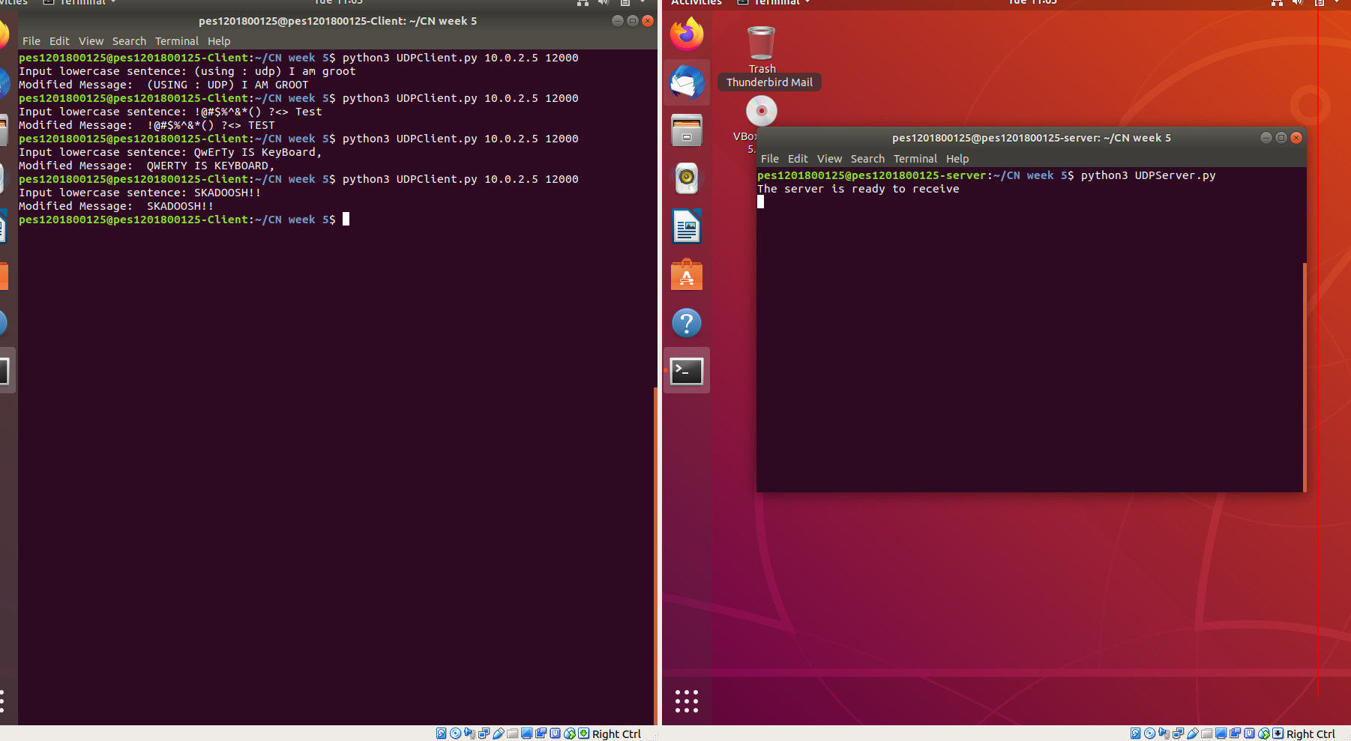
Fig : Tests for UDP (Task 1)

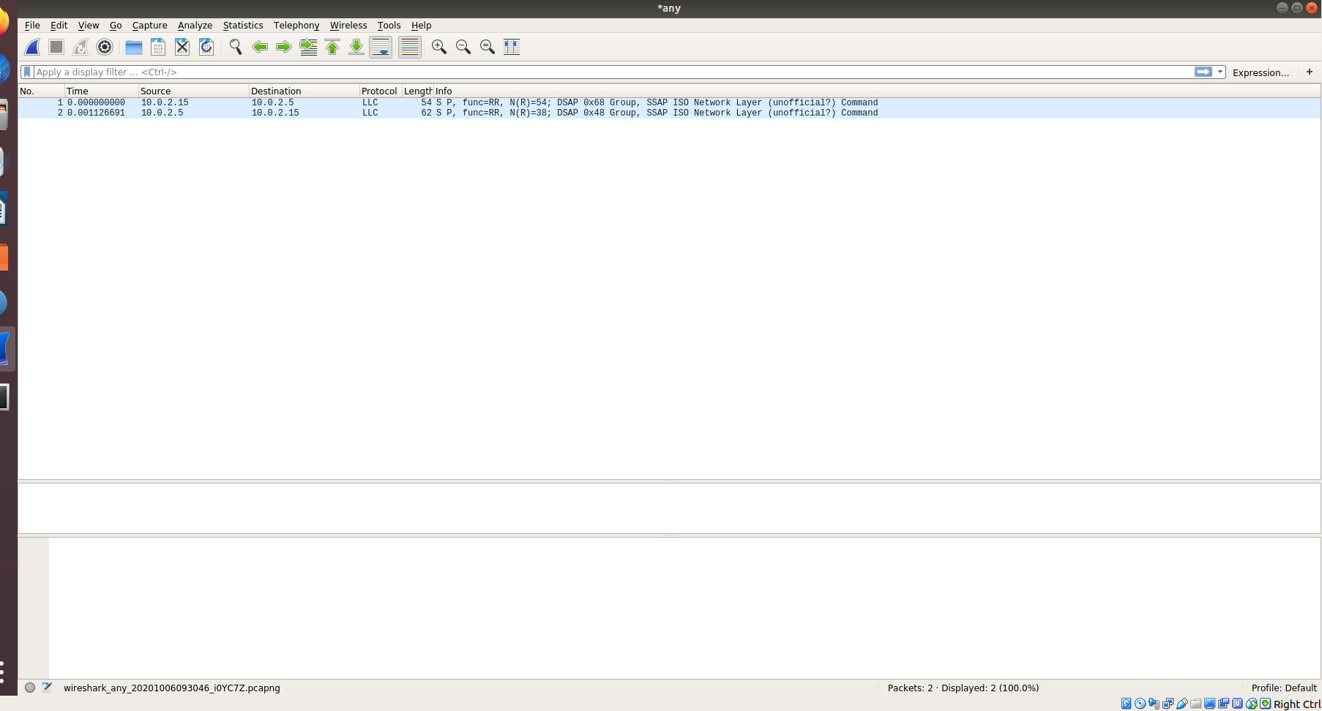
Fig : Packets for UDP (Task 1)

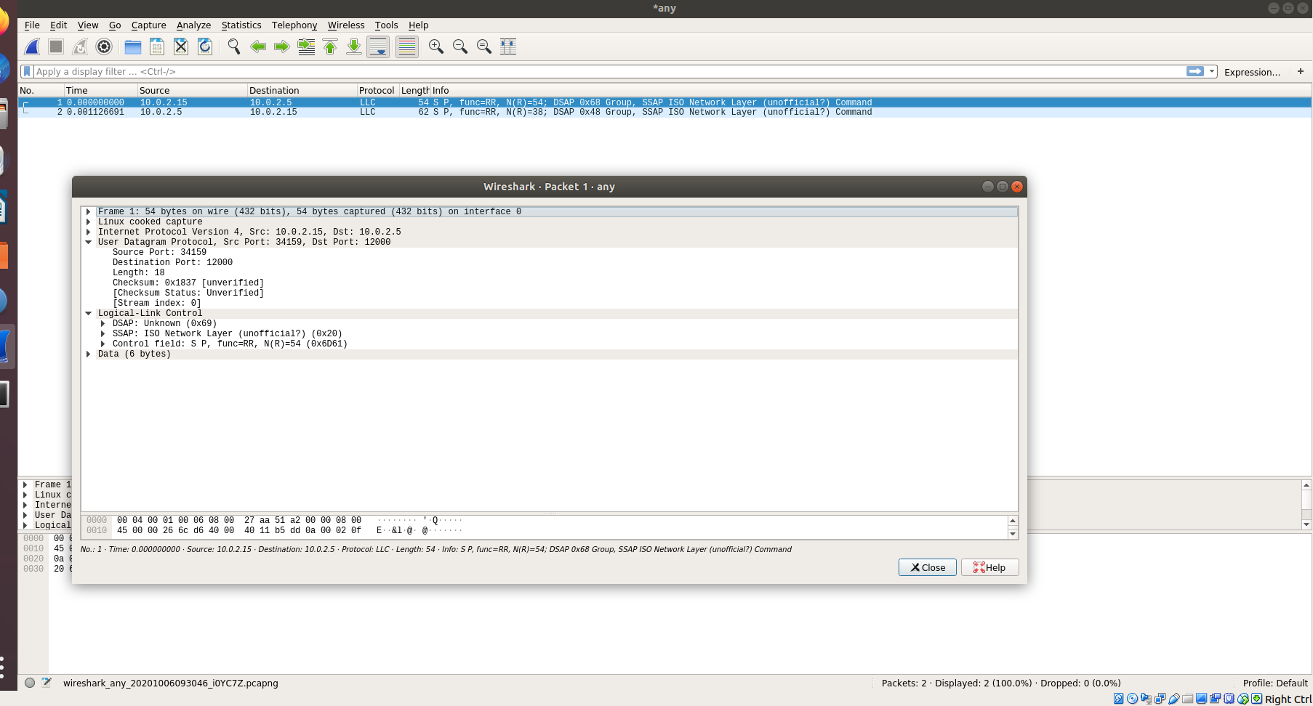
Fig : Request Packet (Task 1)

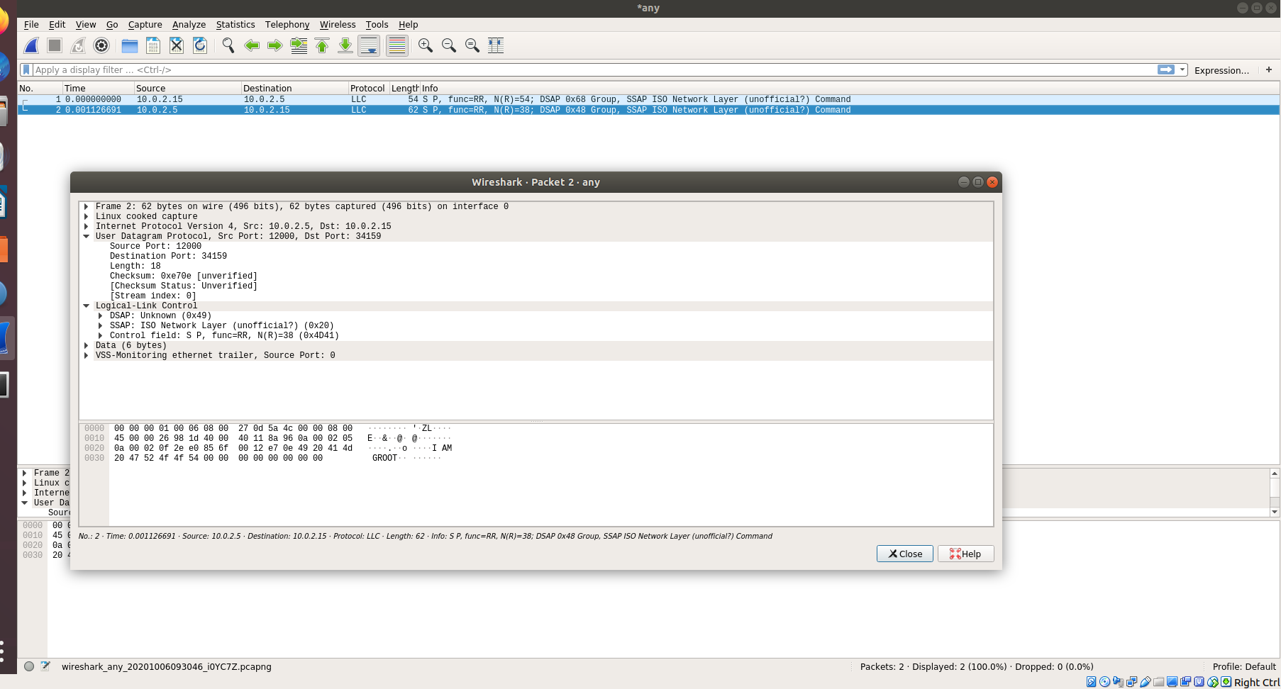
Fig : Response Packet (Task 1)

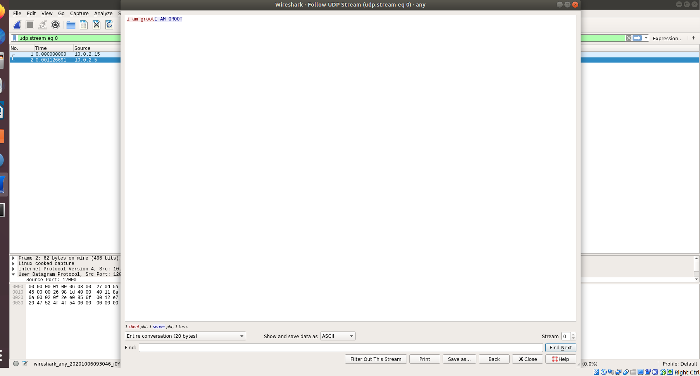
Fig : Follow UDP Stream (Task 1)

- TCP

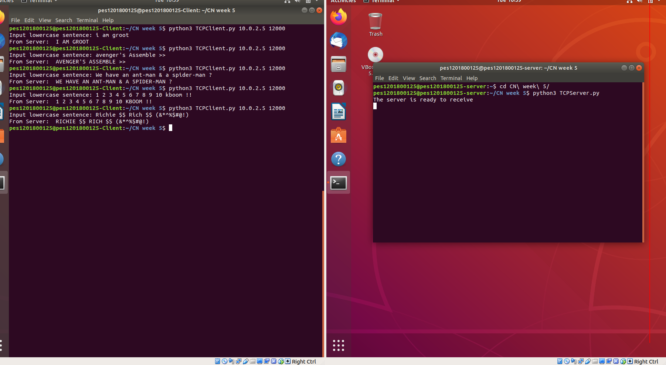
Fig : TCP Tests (Task 1)

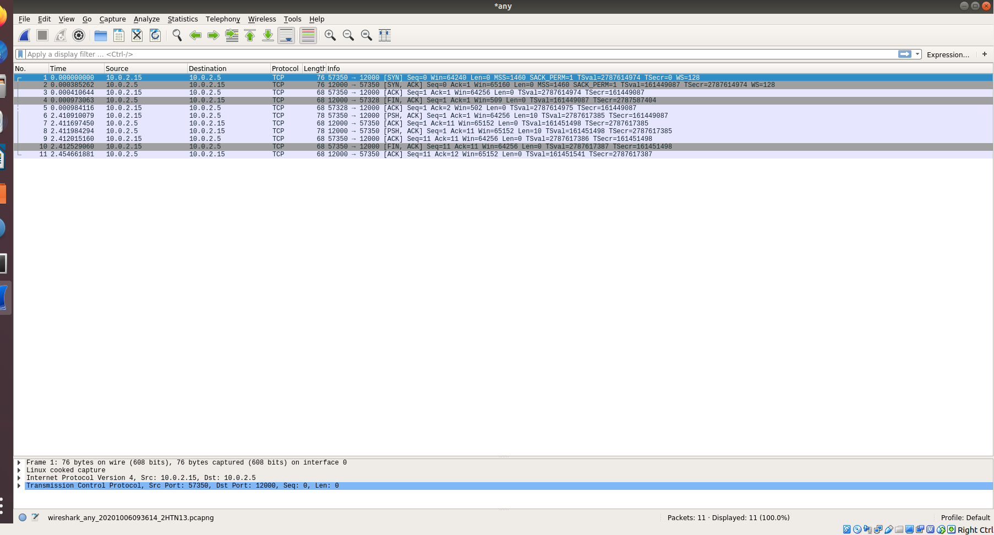
Fig : TCP Packets(Task 1)

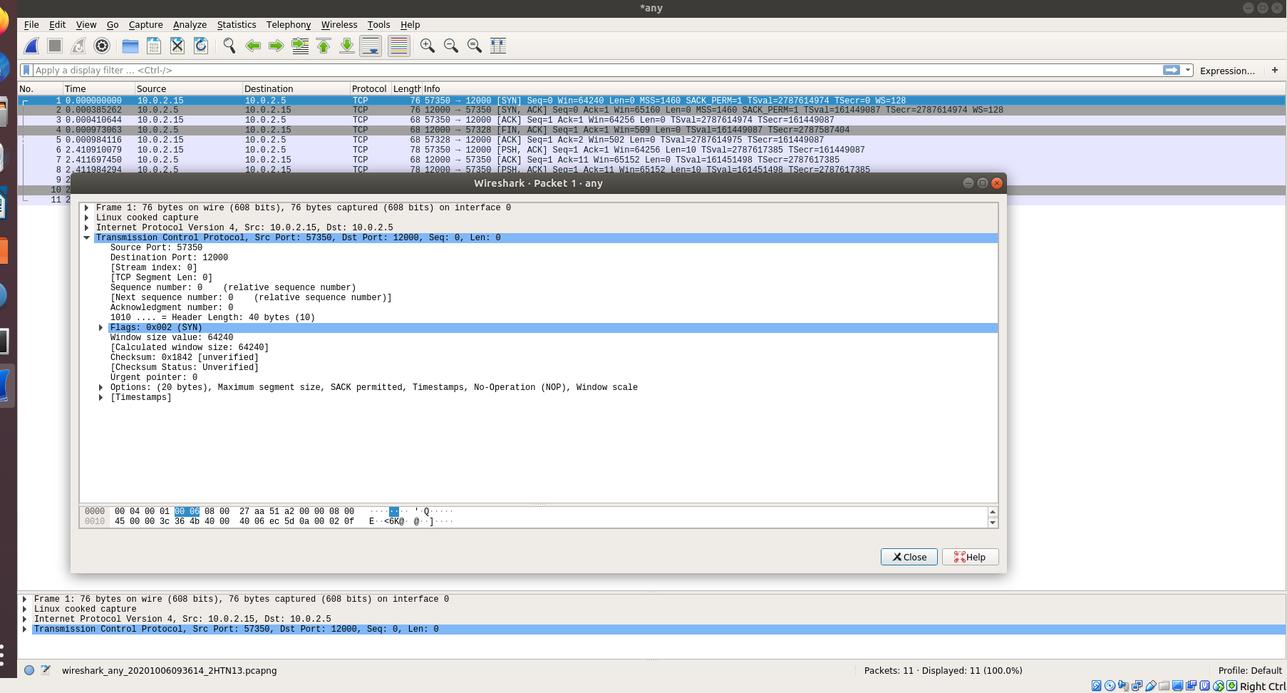
Fig : Request Packets using TCP(Task 1)

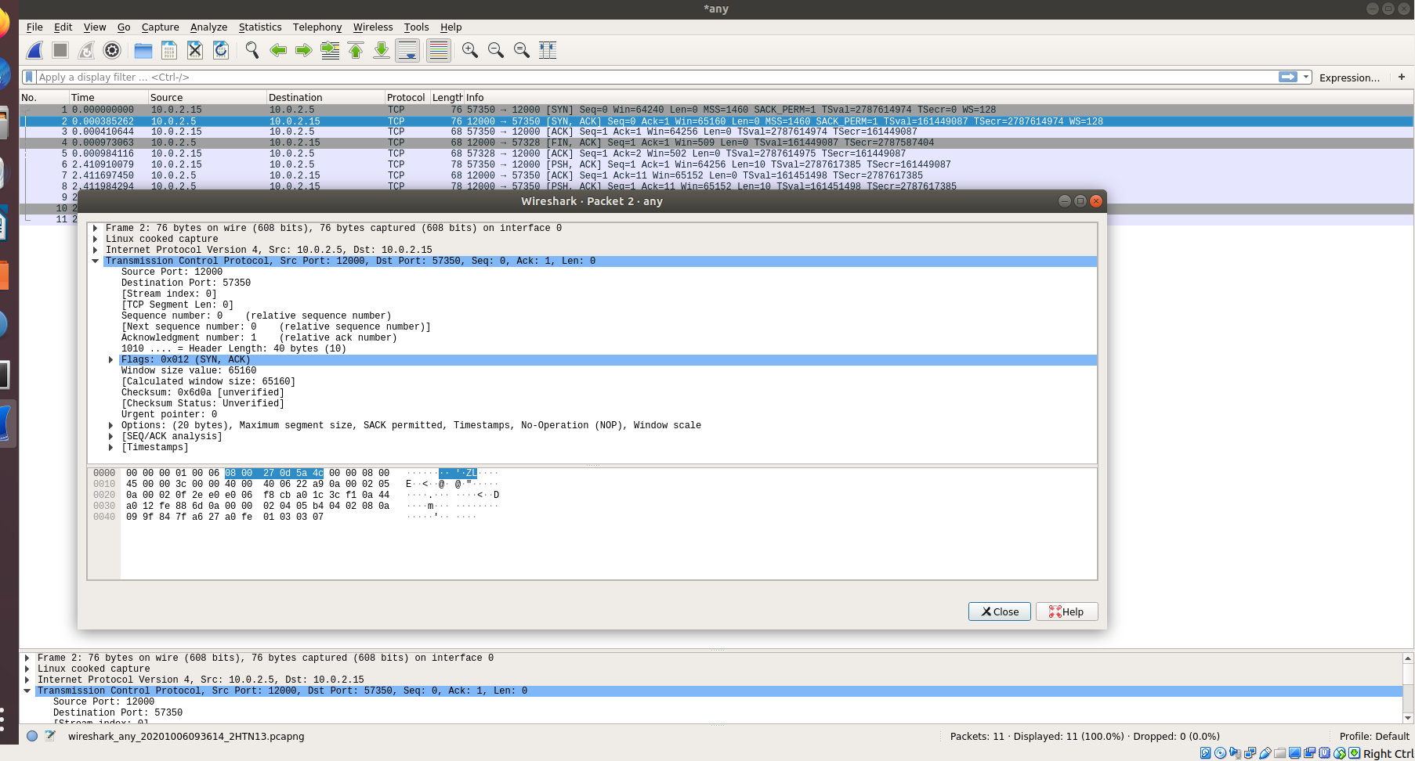
Fig : Response Packet using TCP (Task 1)

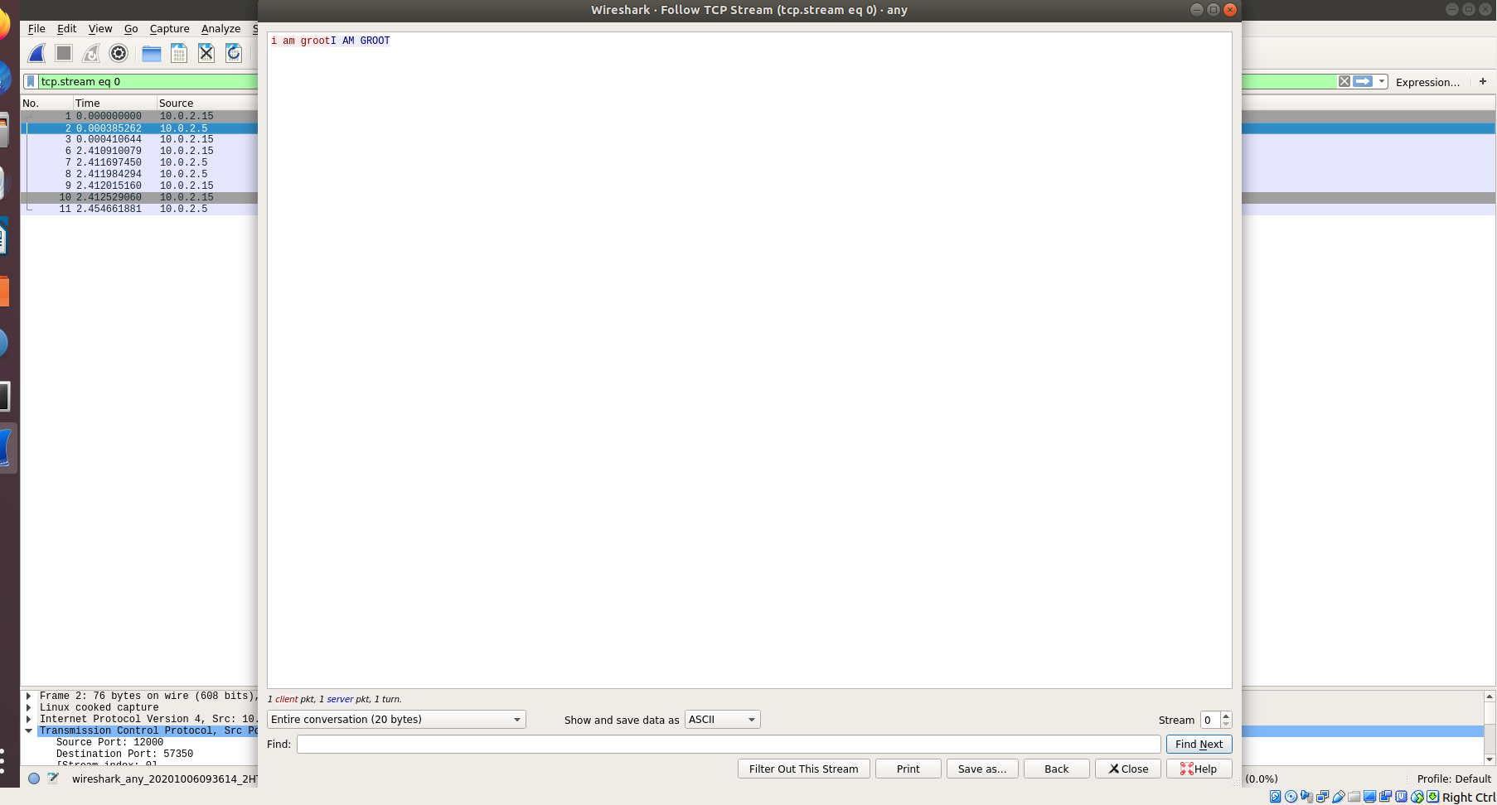
Fig : Follow TCP Stream (Task 1)

TASK 2 :

A file called index.html was created on the server so that it can be served. The other file named index1.html, however does not exist.

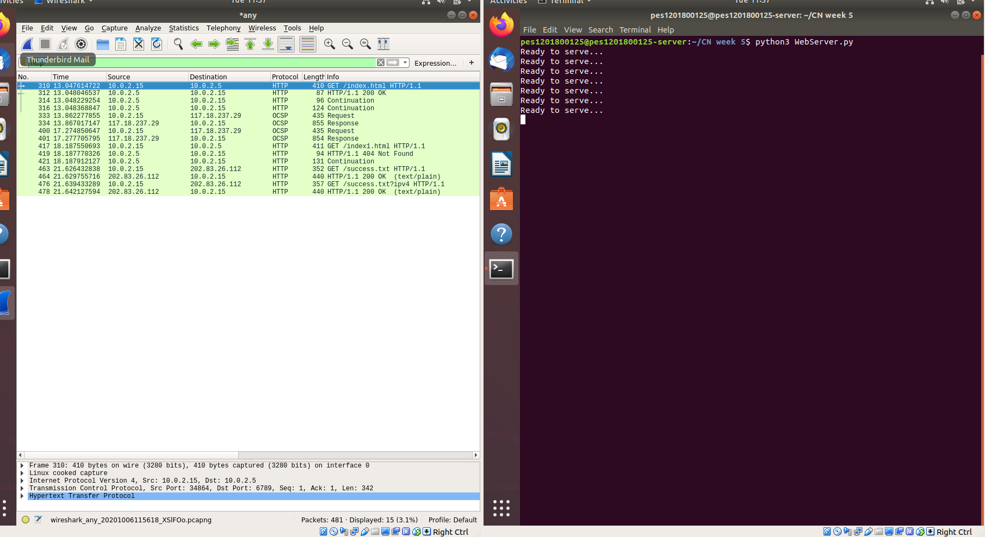
Fig : Task 2 File Server and Packets Capture

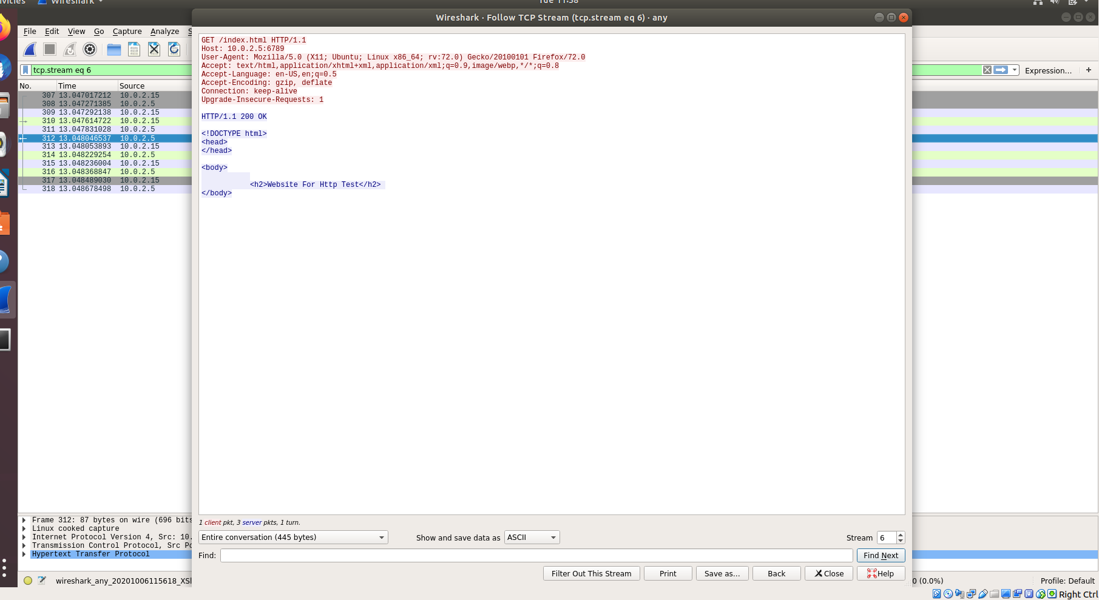
Fig : Serving the Index.html file (Follow TCP Stream)

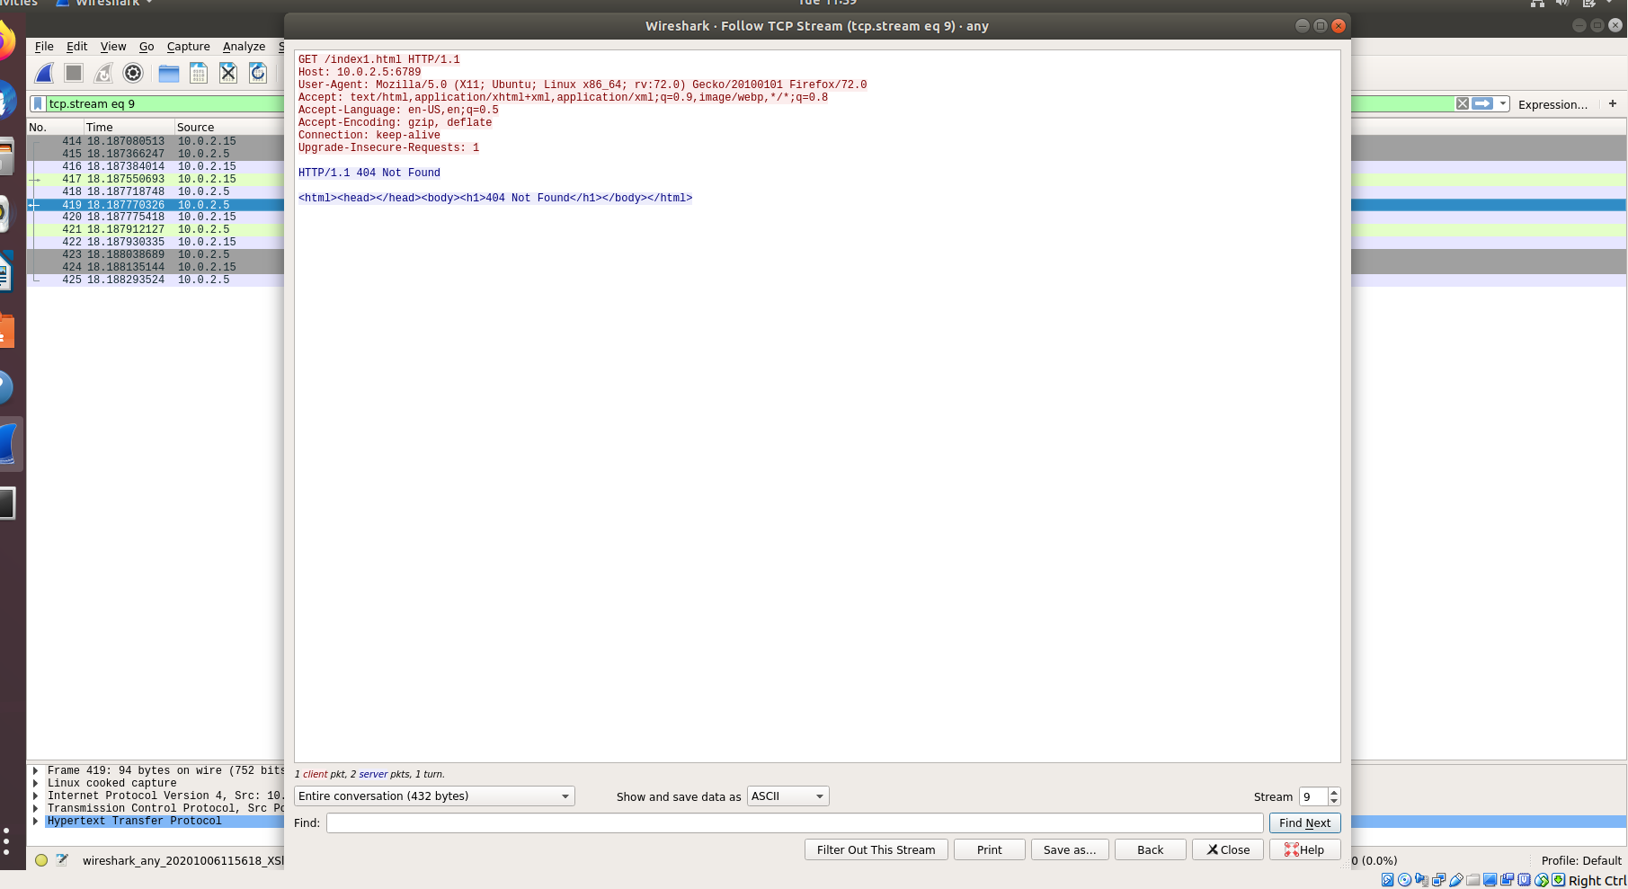

Fig : File Not Found (Follow TCP Stream)

